Roman Shaikh

Student number: 18300989

CS7DS4-Data Visualization

Assignment 2: Graphics Fundamentals

1. BASIC SHAPES AND COLOURS

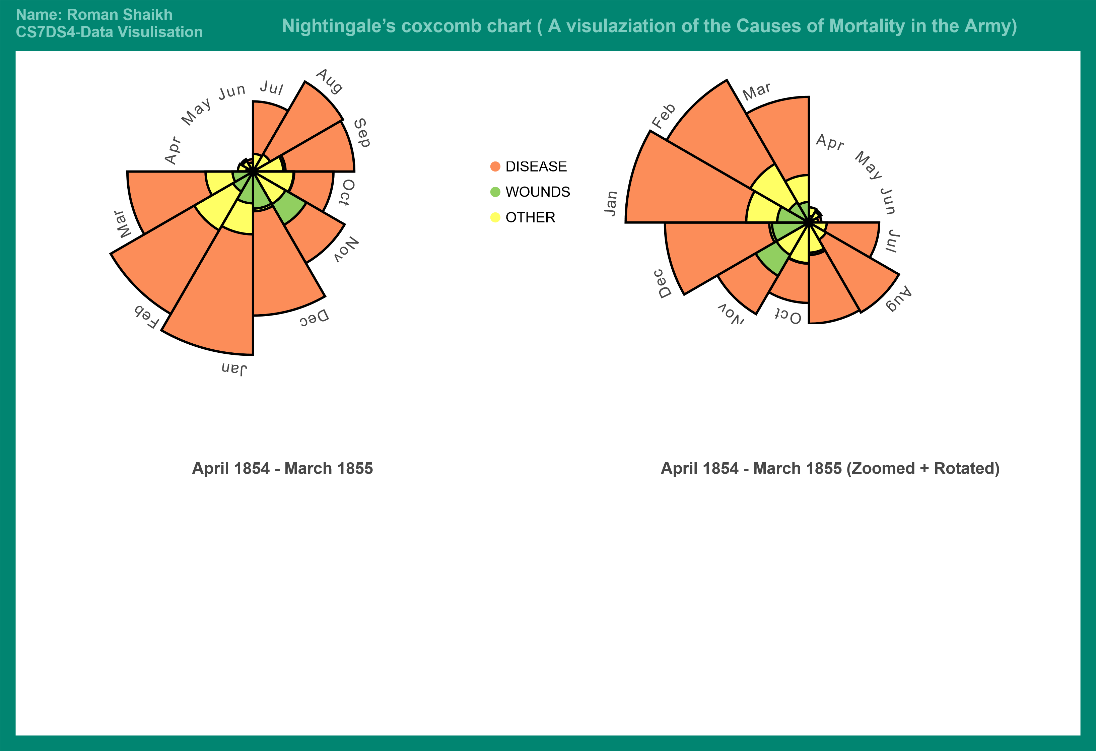

* Git Gist Link: <http://bl.ocks.org/romaan7/5ebd4045333b678e2210f326c23a24c6>

1. MINARD’S MAP

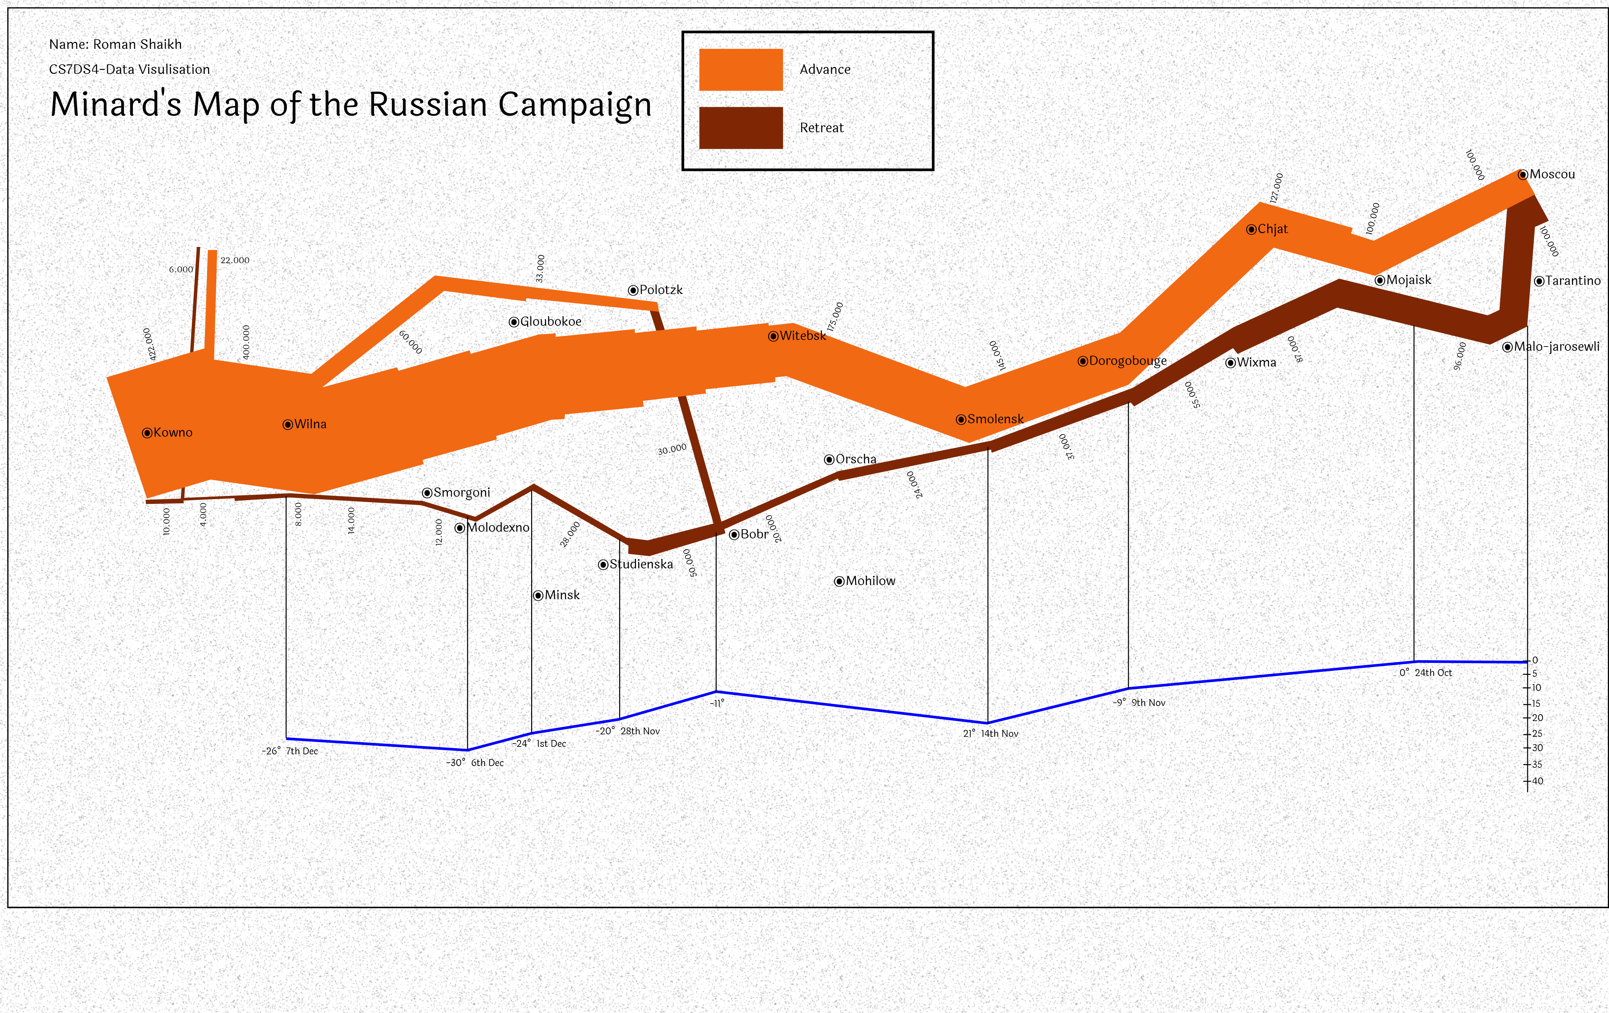

* Git Gist Link: <http://bl.ocks.org/romaan7/84b910cebbcf2138f6dc9e466c8b9e4d>

# Minard’s Map Implementation:

* The chart is drawn using the D3.js library for data visualization.
* The provided dataset contained three categories of data i.e. 1. cities covered (latitude, longitude, the name of the city) 2. The temperature recorded during the time (temperature location and date) 3. and the number of survivors (location, number of survivors and division of the army).
* A standard resolution of 1080px1920p was chosen for the main SVG chart which can be then scaled to fit any resolution of the screen.
* The reference of the original Minard’s map was used to draw the path of the march forward and backward. It was layered over the SVG canvas and the width of the path was traced to get the coordinates points for each area of the survivor count.
* The temperature line was also traced in the same manner. The temperature scale and axis were taken in the same way as on the original map to keep with the consistency.
* The latitude and longitude were then converted into coordinate points w.r.t the standard resolution to ease the mapping process of the cities.
* All this coordinate point data was then loaded in to separate JS objects like city_data, temperature_data, survivor count etc.
* The translations and transformations of elements like survivor, temperature etc. were also calculated in accordance with the original map.
* All of this was then mapped onto the canvas using d3.js version 5 (<https://d3js.org/d3.v5.min.js>) and font family of Laila was used from standard google fonts library(<https://fonts.googleapis.com/css?family=Laila>) for all the texts in the HTML.